

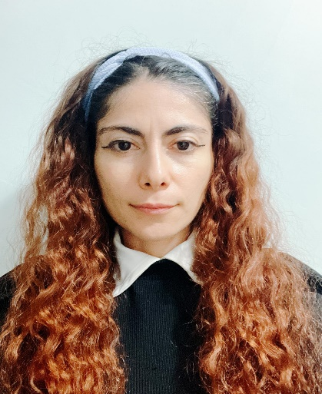

Personal Information

## Date of Birth: 07.02.1988 Nationality: Turkish Drive Licence: -

Contact Information

 Pendik İstanbul, TURKEY  +90546 644 80 08

 [ayfer-durmaz@outlook.com](mailto:ayfer-durmaz@outlook.com)

About Me

With one year and seven months of experience as a Quality Control Analyst, I stay current with industry developments and consistently pursue opportunities for professional growth.

Professional Skills

* MS Office
* MS Windows Tools,
* C++
* Algorithm
* Linux

Languages

* Turkish (Native Language)
* English (A1)

Ayfer DURMAZ

# Quality Control Analyst

Education

* + Istanbul University 2013-2022, Health Management (MA)
  + Tokat Gaziosmanpasa University 2008-2012, Physics Department (BA)

# [Professional Experience](https://www.cv-format.com/)

***Medicavet Pharmaceuticals and Chemicals Trading Inc – ISTANBUL***

*September 2023/ March 2025*

* Collected samples of raw materials, excipients, and primary and secondary packaging components.
* Recorded all sampling activities and maintained proper documentation.
* Performed analytical tests on collected materials in accordance with standard procedures.
* Prepared and reported test results clearly and accurately.
* Communicated findings and test outcomes directly to senior supervisors.

# [Courses](https://www.cv-format.com/) And Certificates Attended

* April 2025 Training on GMP-GLP (GXP) – Instructor: Dr. Musa ALKAN / İstanbul
* February 2025 Ant Technical HPLC Advanced Application Techniques and Column Technologies Training / İstanbul
* 2014 - 2015 English Language Course İstanbul University - İstanbul
* April 2011 Leadership and Management Skills – Pusula Academy / Isparta
* April 2011 Individual Career Management – Pusula Academy / Isparta
* September 2006 – December 2006 Hirfanlı Primary School Directorate Youth Culture Center : Certificates in Web Design, Computer (Office), and Chess / Kırşehir.

Application Details

* Lab-Solution, Chemstation

References

İbrahim AYÇİÇEK - Medicavet Quality Operations Manager - 0530 320 85 64

Sebahat KAYA - Medicavet Quality Control Responsible - 0536 571 51 03

Mustafa AÇIKGÖZ - Medicavet Quality Control Stability Responsible - 0537 727 56 70